1. 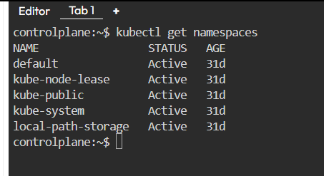How many Namespaces exist on the system?
2. How many pods exist in the kube-system namespace?

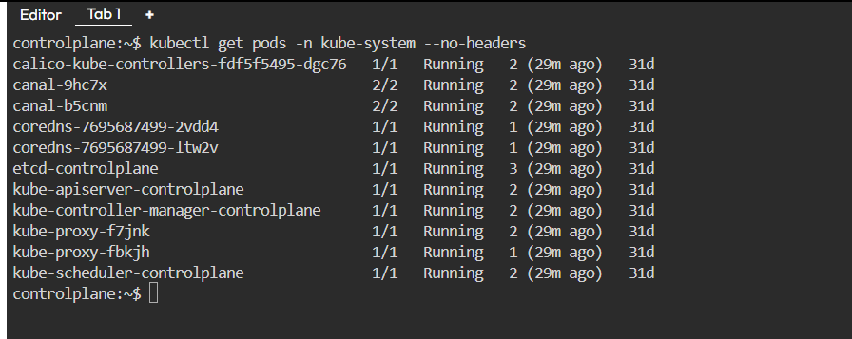

1. Create a deployment with Name: beta

Image: redis Replicas: 2 Namespace: finance Resources Requests:

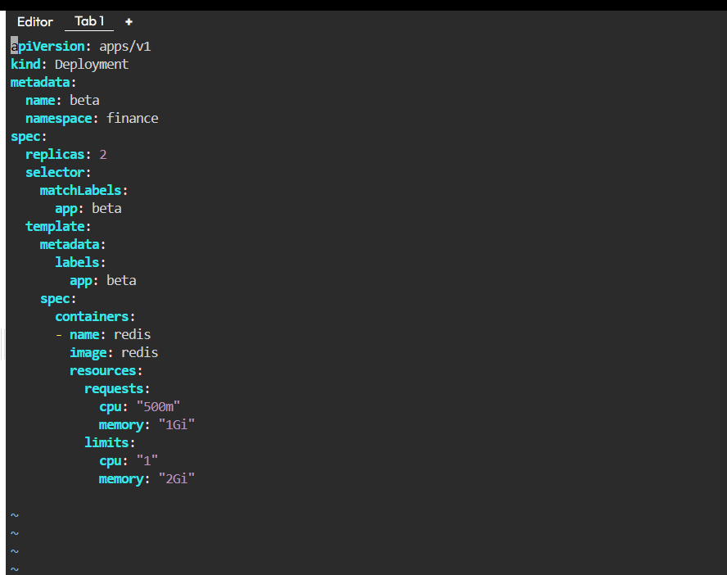CPU: .5 vcpu Mem: 1G

Resources Limits: CPU: 1 vcpu Mem: 2G

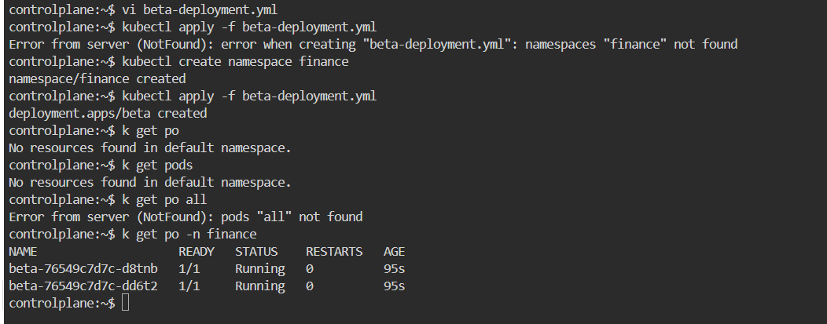

1. 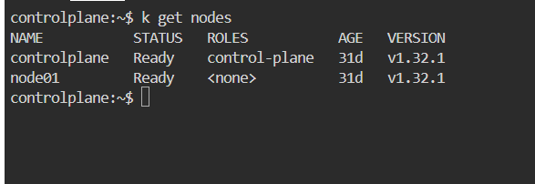How many Nodes exist on the system?
2. Do you see any taints on master?

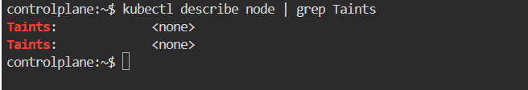

1. Apply a label color=blue to the master node

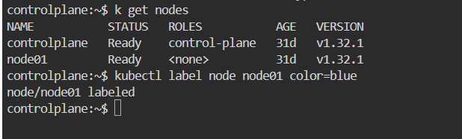

1. Create a new deployment named blue with the nginx image and 3 replicas Set Node Affinity to the deployment to place the pods on master only NodeAffinity: requiredDuringSchedulingIgnoredDuringExecution

Key: color values: blue

